-- Exercise 1: Creating a Non-Clustered Index on ProductName

SELECT * FROM Products WHERE ProductName = 'Laptop';

-- Create Non-Clustered Index

CREATE NONCLUSTERED INDEX IX_Products_ProductName1

ON Products (ProductName);

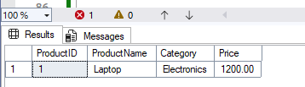

-- Exercise 2: Creating a Non-Clustered Index on OrderDate (instead of clustered)

SELECT * FROM Orders WHERE OrderDate = '2023-01-15';

-- Create Non-Clustered Index on OrderDate (PK is already clustered)

CREATE NONCLUSTERED INDEX IX_Orders_OrderDate1

ON Orders (OrderDate);

SELECT * FROM Orders WHERE OrderDate = '2023-01-15';

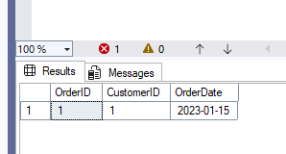

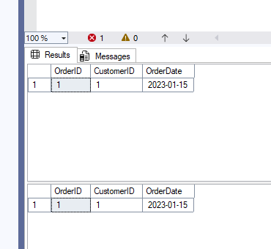

-- Exercise 3: Creating a Composite Non-Clustered Index

SELECT * FROM Orders WHERE CustomerID = 1 AND OrderDate = '2023-01-15';

CREATE NONCLUSTERED INDEX IX_Orders_CustomerID_OrderDate1

ON Orders (CustomerID, OrderDate);

SELECT * FROM Orders WHERE CustomerID = 1 AND OrderDate = '2023-01-15';

